**Release Note**

JiBe

[Heat Map in JIBE Office]

Version 1.0

**Date:** <10-11-2016>

Table of Contents

1. Introduction 3

2. About This Release 3

3. New Features 3

4. Fixed Bugs 3

5. Known Issues 3

6. Improvements/Enhancements 4

7. Removed/Retired Features 4

# Introduction

The document communicates the major new features and changes in this release of the Heat map in Jibe office. It also documents known problems and workarounds.

# About This Release

This release focuses on:

The "heat map" feature will be added to all screens where crew "creator" and "modifier" appear. This will be done both on places they appear directly on the page (e.g. worklist job) as well as places where they appear under the "I" info icon.

# New Features

The following new features appear in this release:

The heat map should be generated only for crew members and not office users.

The heat map will contain following elements:

1. **Sea service in months:**

Displays the total number of sea days as per current date for the crews. Present them on monthly.

1. **Average evaluation :**

Displays average score of all previous evaluations as per current date for the crews.

1. **Crew Cards :**

Displays any card issued as per current date for the crews.

Color coding will be as follow:

**Red light:** When a crew member is in the lowest 20% of the scores (example: if a crew has an average score of 20, and more than 0 percent of the company received higher score, he will receive red light).

**Yellow light:** All scores within the range of over 20% and under 80% of the scores

**Green light:** All scores from 80% and above

**Grey light:** For NTBR/Inactive crew members

Color coding will be configurable for Jibe Admin, so JIBE Admin will be able to adjust on what percentage the hit map displays green yellow and red. Add it to the Crew Setting page.

**Hovering**: when user hover above the hit-map, a detailed popup will open, displaying the following information:

1. **Sea service in months:** Sea service will calculate sea days and will present them on a monthly display and sea service months in current rank is according to current rank will calculate sea days.
2. **Evaluation:** The average evaluation score and the decile percentage of the crew comparing to other crew members with the same rank and evaluation ranking in the company (Actual percentage)
3. **Crew Cards:** Displays if a crew received card or not, and if yes, what was the issue date and reason for it.

**Description:** This heat map functionality appears on bottom of some pages like worklist job (See screenshot)

1**.** View Job



2. Add new job

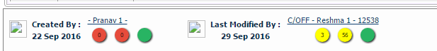

3 Task Details page

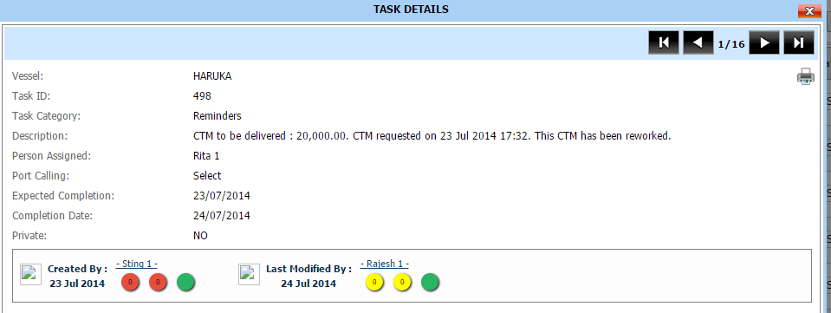

And also places where the appears under the ‘I’ info icon (See screenshot)

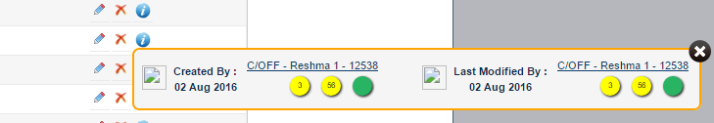

The digit in circle indicates following:

1. **Sea service in months.**



1. **Average evaluation**
2. **Crew Cards**

4. For office users, heat map should not be generated.



5. For NTBR/Inactive crew members, Evaluation ranking is ‘N/A’ and circle color is light grey.

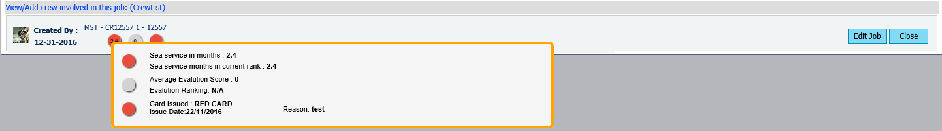

**Hovering**: when user hover above the hit-map, a detailed popup will open, displaying the following information (See screen shot)

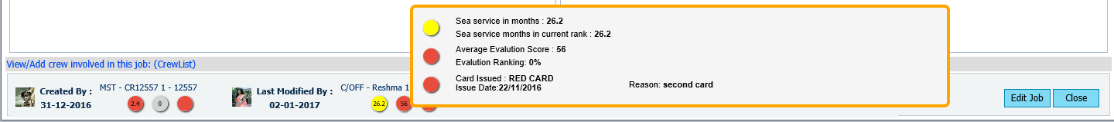

1. **Sea service in months:** The contracts will calculate sea days and will present them on a monthly display and sea service months in current rank is according to current rank will calculate sea days.
2. **Evaluation:** The average evaluation score and the decile percentage of the crew comparing to other crew members with the same rank and evaluation ranking in the company (Actual percentage)
3. **Crew Cards:** Displays if a crew received card or not, and if yes, what was the issue date and reason for it. If crew received red or yellow card then card color will be red or yellow respectively. If crew not received any card yet then color will be green by default.

**Color Coding Examples:**

**1.** The color for Sea service in months, Sea service months in current rank and Number of contracts in the company is depend on crew’s actual total no. of days on board appears in which range.

**Ex.** If crew ‘A’ is 120 days on board then if he comes in top 20 % then color will be green ,if he comes in bottom 20% then color will be ‘Red’, if he comes in range of 21-79 then color will be ‘Yellow’.

**2.** The color for Average evaluation, Evaluation ranking is depending on actual percentage of crew comparing to other crew members with the same rank.

For NTBR/Inactive crew members, Evaluation ranking is ‘N/A’

Formula for Evaluation ranking

**n=**number of crew members

**r=**current rank when sorted by order

Ranking percentile= (n-r)/ (n-1)*100

**Ex.** If a crew has the 5th best score out of 100 crew members, he will be ranked 95%.

Then to calculate Evaluation ranking

There are 61 crew members, so n=61

Crew is ranked 5th, so r=5

Ranking percentile = (61-5)/ (61-1)*100=93%

Check Average evaluation comes in which range of color.

**3** Crew card color is depends on which colored card issued to crew red or yellow, if no card issues then color will be green.

# Menu/Access added or removed

Not Applicable

# Improvements/Enhancements

Not Applicable

# Fixed Bugs

Not Applicable

# Known Issues

Not Applicable

# Removed/Retired Features

Not Applicable